DATE: 04.10.2019
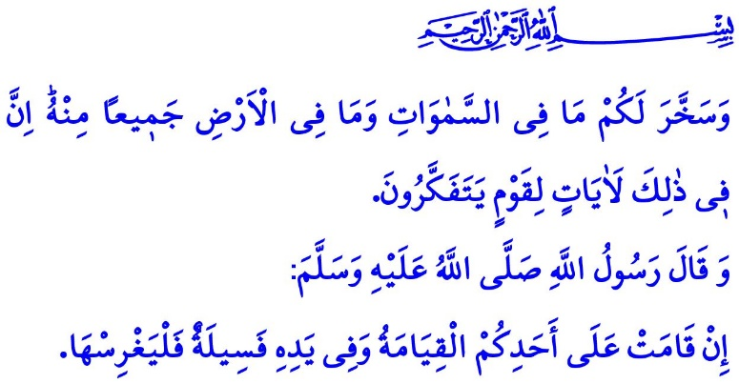
LET US PROTECT OUR HOME: PLANET EARTH
Honorable Muslims!
Pondering over carefully, we can see that all creatures around us, from tiny little ants to inconceivably large planets sailing in their orbits, are all Allah the Almighty's (swt) works. With His unexampled power and inimitable artistic style, our Lord has created a thousand and one kinds of living beings. Each and every single one of them is a blessing for us, and we will account for each and every blessing bestowed upon us. In the verse I have recited at the beginning of the khutbah, this truth is referred to as follows, “Allah has subjected to you, as from Him, all that is in the heavens and on earth. Behold, in that are Signs indeed for those who reflect.”
Dear Believers!
The sole authority to determine the value of any and all things is Allah (swt) alone. Having created any creature for a specific reason to serve a specific purpose, Allah the Almighty (swt) states, “Not for (idle) sport did We create the heavens and the earth and all that is between!” The universe, with all its unseeably atoms of certain meaning, is a balanced and sublime whole. All created beings on this planet on which we came to life have a distinctive function and value.
Dear Muslims!
It is important to note that Allah (swt) has not created a universe independent of His watch and left it unoverseeable. All creatures speak of and belong to Him. By Him is overseen all existence. This is referred to in the Holy Qur'an as follows, “Of Him seeks (its need) every creature in the heavens and on earth: every day in (new) Splendor doth He (shine)! Then which of the favors of your Lord will ye deny?”
In this regard, we are responsible towards the nature and the environment, as our respect for the Lord's work and sovereignty would require. Causing harm and damage to the nature by going against Allah's (swt) rules and laws means the negligence of our responsibilities towards Him.
Dear Believers!
We are the members of the Prophet Muhammad's (saw) ummah, who would spectate with affection even a mountain and say, “We love Uhud, and Uhud loves us.” We follow his path, who says, “If the Resurrection were established upon one of you while he has in his hand a sapling, then let him plant it.” We take him as our guide and example who would always warn his companions about protecting the rights of animals.
Dear Muslims!
We are going through bitter times when on the one hand tons of bread are wasted and thrown in the garbage, and on the other hand many people lose their lives due to hunger and poverty. How sad it is that today people who are the captives of their worldly desires and ambitions fail to establish a friendly, fair and humane relationship with the nature. They set on fire forests that are the source of breath for all living beings, desertify the earth with the products grown on which we feed ourselves, and pollute the rivers that satisfy our thirst.
For how long yet will we have to put up with the fact that tons of food are being wasted in the garbage while our civilization considers unwelcome even a tiny little bit of breadcrumb thrown away on the ground? For how long yet will we carelessly keep recyclable waste in containers on the streets?
We should know, however, that we can be peaceful and healthy to the extent we treat the nature with love and compassion. Otherwise, the damage will not hit the nature only, but us, as well. People are warned in the Holy Qur'an as follows, “Corruption has appeared throughout the land and sea by [reason of] what the hands of people have earned so He may let them taste part of [the consequence of] what they have done that perhaps they will return [to righteousness].”
Honorable Believers!
We humans are the Most Merciful Allah's (swt) caliphs on earth. Being a caliph means being held responsible; that is, being the protector of the earth, not its landlord. It means making use of the earth in accordance with Allah's (swt) approval. It means not spoiling and damaging the earth.
Then, let us be more sensitive towards the nature that is entrusted to us by our Lord who keeps creating and managing. Let us not forget that one day we will give an account for everything to the Owner of all things entrusted to us. Let us continue our lives as conscious of the fact that the earth belongs to all living beings, not to humans only.
Before I conclude today's khutbah, I would like to remind an important point. The next Sunday following the fajr prayer from all mosques, we will go planting saplings on the occasion of the Mosques and Religious Officials Week, with your participation, our honorable congregation. You and your family members are all invited for this meaningful activity.

Jathiyah, 45/13.
Anbya 21/16.
Rahman, 55/29.
Bukhari, Maghazi, 82.
(Ibn Hanbal, III, 184)
Rum, 30/41.s General Directorate of Religious Services

